|  |
| --- |
|  |
| Question of EServices |
|  |
|  |
| ©MetaShare Inc. |
| **11/27/2015** |

**修订记录**

|  |  |  |
| --- | --- | --- |
| **日期** | **修改人** | **修改说明** |
| 2015-11-27 | Serena.li | 初稿 |
| 2015-12-01 | Adam Wang | Answer question 1 -4 |
|  |  |  |

Table of Contents

1 Introduction 1

1.1 Purpose 1

1.2 Background Purpose Introduction 1

2 Content 1

2.1 Sections 1

2.2 Billing information 1

2.3 Job Parameters 2

2.4 Job Designer 2

# Introduction

## Purpose

Record issues.

## Background Purpose Introduction

Facilitate cooperation

# Content

## Sections

UI Mock ,Step 4

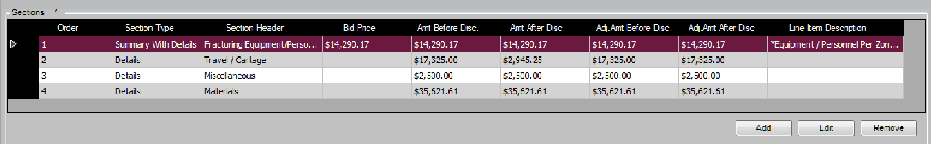

SectionsControl Not found, whether the new control？

Answer: Just leave this page for now, Sanjel team will build new pricing page control

## Billing information

UI Mock ,Step 4 Billing informationControl Display as：



Actually get to control the display of：

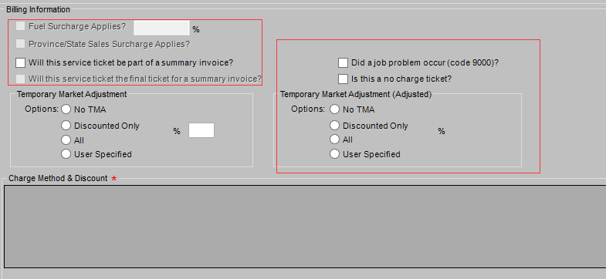

Do we need to recreate the control or disable these red-bordered area？

Answer:

Just leave all of these hidden areas visible for now for first step. We haven’t have finish the requirement yet.

## Job Parameters

UI Mock ,Step 3 JobParameters Display as：

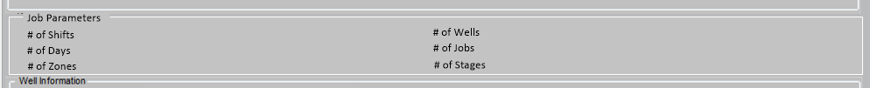

What does Job Parameter means?

Answer: JobParameter class has been added in code.

## Job Designer

UI Mock ,Step 6 Job Designer Display as：

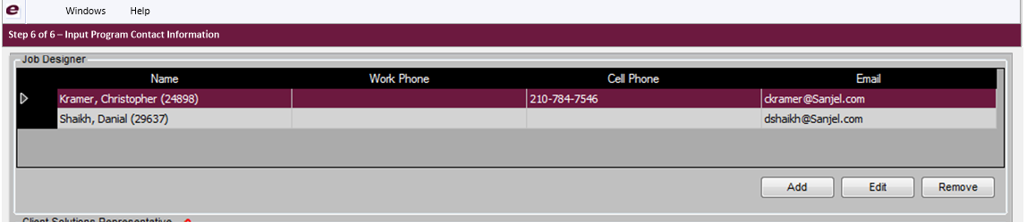

I find EmployeeInfoControl used in SanjelContactInfoControl, in which its HeaderText is set as "Job Designer". So I think EmployeeInfoControl is same as JobDesignerControl, I want to use EmployeeInfoControl in InputProgramContactInformationControl ,Can I ??

If I should created a new JobDesignerControl, the corresponding Entity is Employee?

Answer:

You are right, you should use EmployeeInfoControl instead of JobDesignerControl. The JobDesignerControl was created wrongly by not following the pattern. Originally all contact controls were same, by that time there was only EmployeeInfoControl, the only difference was different Header Text and the red flag for mandatory. Later, we add some other fields in FieldSupervisorControl and SalesPersonInformationControl.

So in Client Solution Tool, you may use only EmployeeInfoControl for now.